Objectives for redesign

**Website: Florida Energy Systems Consortium (FESC)**

The objectives of the redesign is to create a responsive website to promote collaboration among the energy experts at the Florida Energy Systems Consortium’s (FESC) 12 supported universities to share energy-related expertise.

The consortium was formed to:

* research and development on innovative energy systems
* explore alternative energy strategies and improved energy efficiencies leading to an expanded economic development for the state

The current design failures are:

* It is does not provide a seamless user experience across devices and is not responsive
* The information architecture is complex and confusing making it hard to navigate
* It looks outdated and does not seem to comply with the accessibility guidelines
* The website performance is below standard

**State of the current site**

To assess the current state of the website the following key points are taken into consideration:

* Accessibility
* Mobile-friendliness
* Website Performance

Below are the results of the tests run in these key areas.

**Accessibility audit**Accessibility audit is an important element of a design process. An accessibility audit is required to establish and measure the ease of use and access of a website by a wide range of people, taking into account users with disabilities and the visual impairments. The results of an audit help to provide recommendations where necessary.  
Used the following tools to run an accessibility audit on the website.

* Ran accessibility audit using **Accessibility Valet** - tool that checks Web pages against either Section 508 or W3C Web Content Accessibility Guidelines (WCAG) accessibility compliance. The website **did not pass** the WCAG3 guidelines audit.

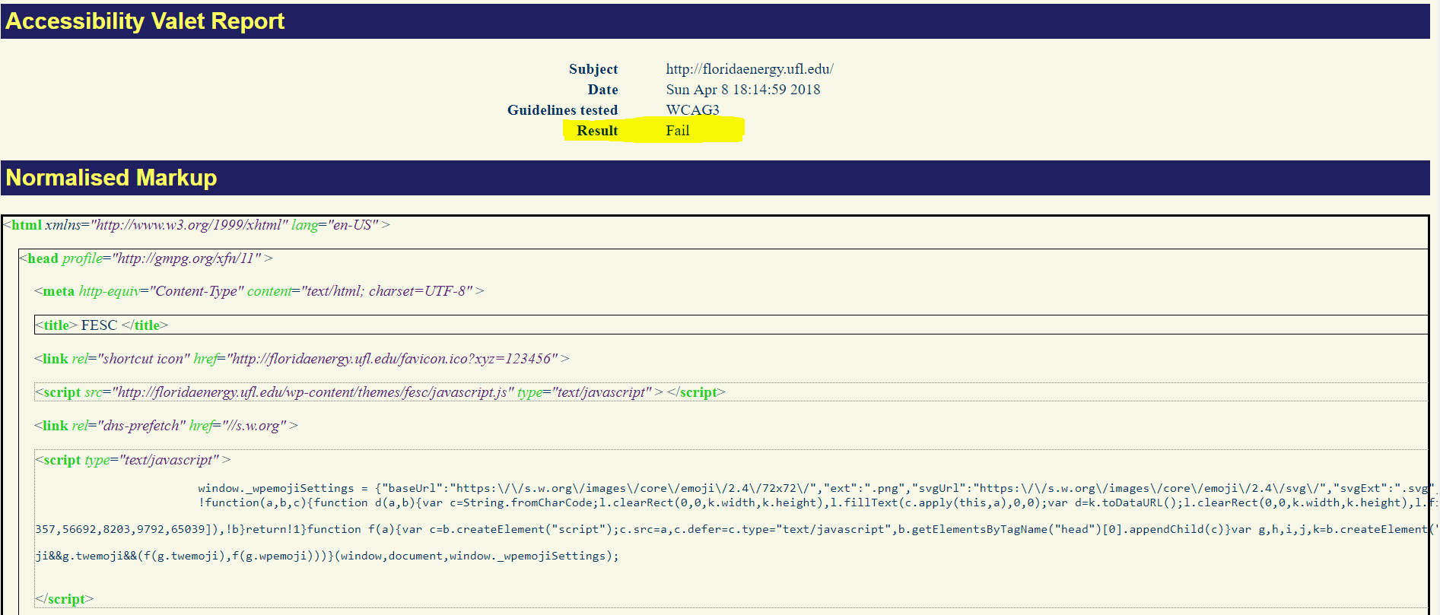  
View full report [here](http://valet.webthing.com/access/htnorm?url=http%3A%2F%2Ffloridaenergy.ufl.edu%2F&suite=WCAG3&xslt=compact).

* Ran an accessibility audit on **Accessibility Checker** - the audit resulted in **45 known problems** and 238 potential problems.

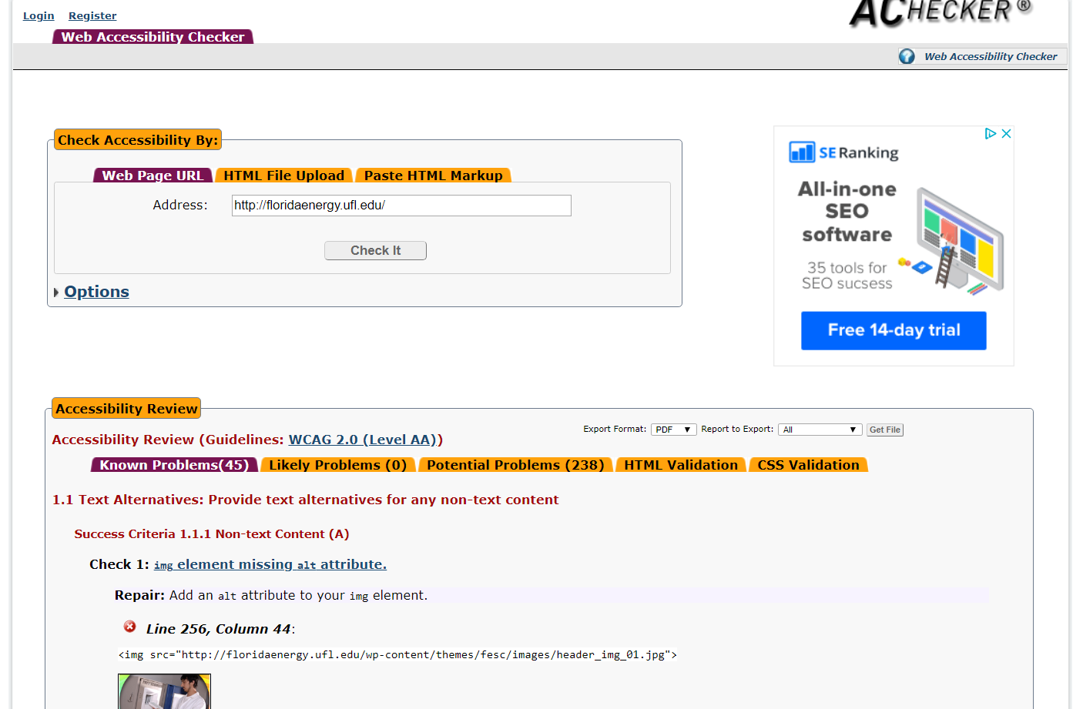  
View full report [here](https://achecker.ca/checker/index.php#output_div).

# **Mobile friendliness**

With the increasing usage of mobile devices, it is crucial to design websites to be mobile friendly.   
To test the mobile friendliness of the website, used the online **Google Mobile-Friendly Test** tool. The results were negative.   
The tool accessed the website to be **not mobile-friendly** and recommended improvements in the following areas:

* clickable elements too close together
* set viewport
* text too small to read
* content wider than screen

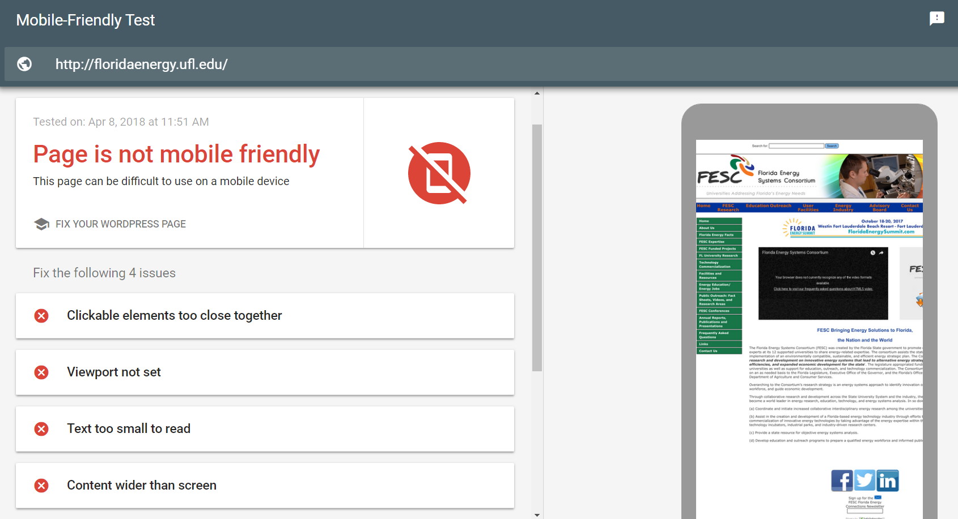  
View full report [here](https://search.google.com/test/mobile-friendly?utm_source=mft&utm_medium=redirect&utm_campaign=mft-redirect&id=5OOx8M2vQS-FWzqMY9uC2Q).

**Website Performance**It is crucial to test the website on various browsers at different consumer connection speeds to ensure the website is optimized for the optimal user experience, and [www.webpagetest.org](http://www.webpagetest.org) does you do exactly that. The test results are posted below.

# View full report [here](https://www.webpagetest.org/result/180408_75_db5f3dc4ac28b2e9a2500be2fda4bb36/).

**User Research**

The core users of the website are:

* Florida Universities
* Partner institutions
* Energy industry

Additionally, FESC’s training and educational efforts are aimed at:

* community college trained technicians,
* bachelors level students,
* graduate researchers,
* and practitioners who seek to update their existing skills.

The users are looking for information on:

* various FESC funded projects
* FESC’s statewide education programs - The Education program has three focus areas, community college programming at the AS and certificate level, nuclear energy education, and a Masters degree in sustainable energy.
* Outreach programs
* education and outreach programs
* User facilities available at the universities and partner institutions
* Latest development in the energy industry
* FESC’s Advisory board
* Contact information

**Recommendations**

* Create a responsive website that is compatible across various devices
* Simplify the information architecture and create a consistent and intuitive navigation pattern across all pages so users can find what they are looking for easily
  + Add the primary navigation in the footer bar
  + Use breadcrumbs on pages to indicate the navigation trail
  + Simplify the number of navigation options on each page
* Establish a visual hierarchy by arranging and organizing website elements so that users can identify the important elements first.
* Ensure the site adheres to accessibility standards
* Include a blog option